Volt VAR Summary Report Generator: Manual

Julian Chan, Undergraduate Summer Intern 2017

Updated: August 9, 2017 8:38 AM

**Table of Contents**

**Program Overview1**

**How to Run the Program2**

**Appendix 1: Formatting the Data File Input5**

**Appendix 2: Usage of the Substation Name6**

**Appendix 3: Choosing the Bound Type6**

**Appendix 4: Entering the Bounds8**

**Appendix 5: Plot Generation12**

**Notes12**

**Program Overview**

**See Appendix:**

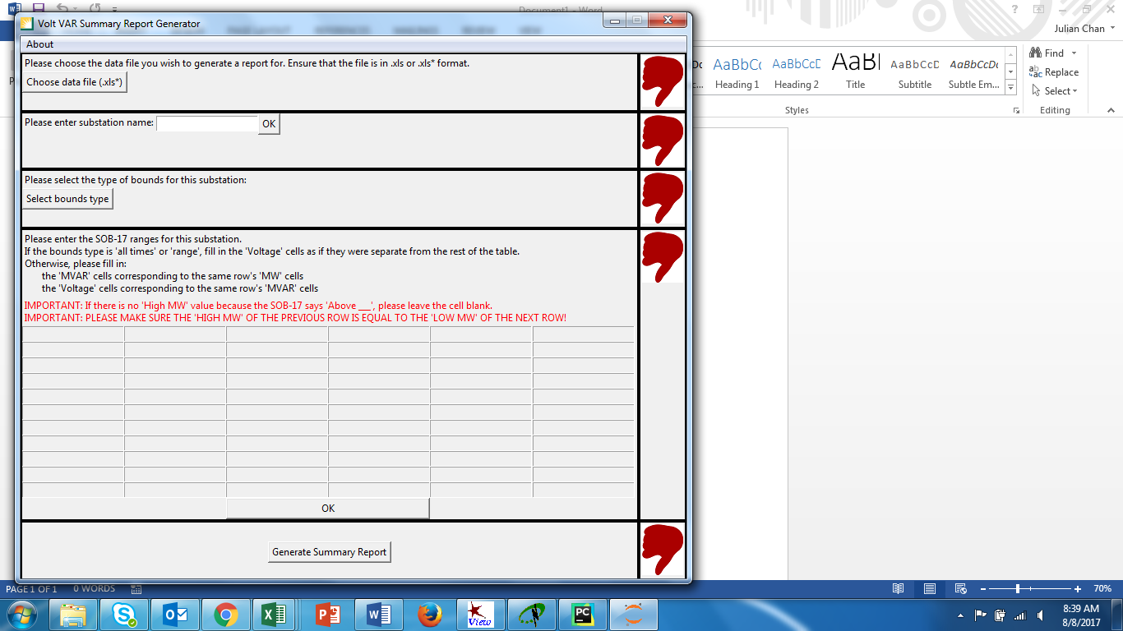

1

5

2

3

4

**How to Run the Program**

(IMPORTANT: User must have Python 3.3+ installed and added to the system PATH environment variable. If Python installed using the Anaconda distribution, everything should work smoothly.)

|  |  |
| --- | --- |
| 1. Locate the file called *main.py* |  |
| 1. Right-click the file 🡪 Properties 🡪 General 🡪 Location 🡪 Copy the entire path |  |
| 1. Open command prompt by pressing Windows + R, typing “cmd”, and pressing Enter |  |
| 1. On the command line, type “cd “ and then Right-click 🡪 Paste to paste the entire path of the *main.py* file |  |
| 1. On the command line, type “python main.py” and the GUI will start up |  |

**Appendix: Formatting the Data File Input**

1

* Ensure that the file is a Microsoft Excel (extension .xls, .xlsx, .xlsm) file
* The program assumes that the data is arranged in columns and properly labeled
  + Required columns and labels (exactly as shown here): Date, Time, MW, MVAR, kV
  + The columns need not be consecutive; they just need to be labeled as above

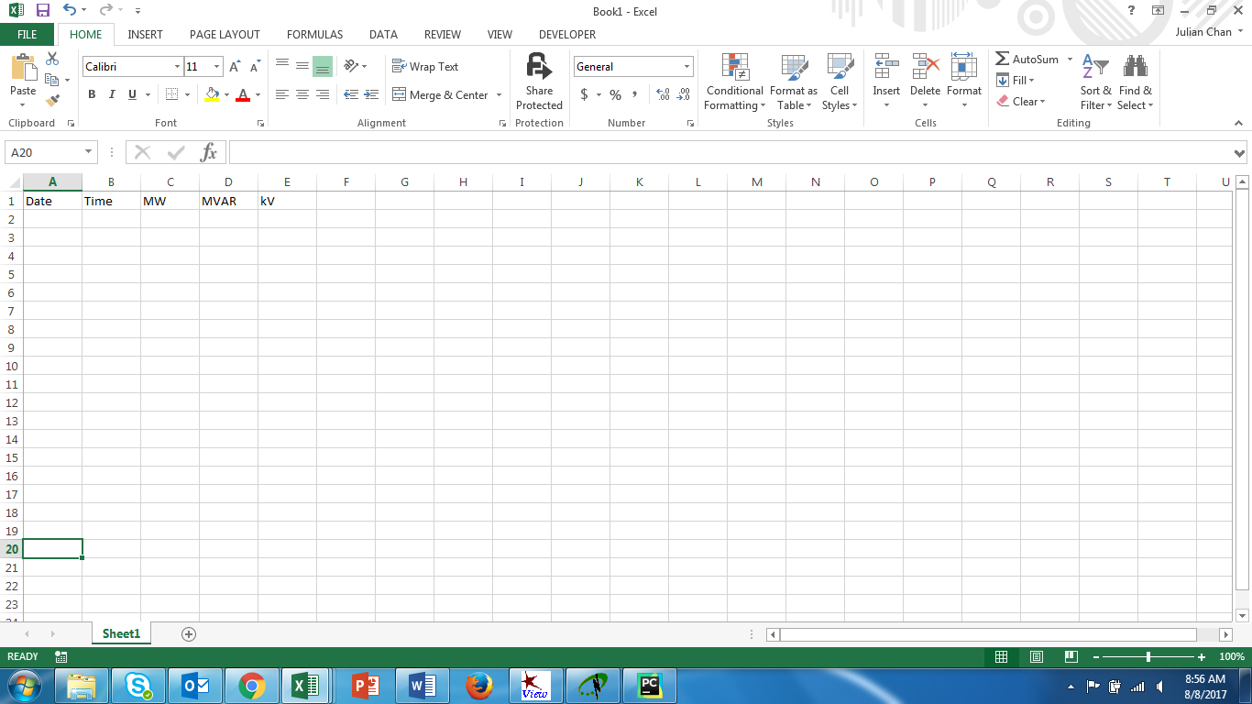

* The program assumes that in the same Excel file, in addition to the data, there be 2 other worksheets named:
  + “VAR Schedules” (currently for 66kV only)
  + “Volt Schedules” (for 66kV and 500kV)

and **must be in the exact order shown below**.

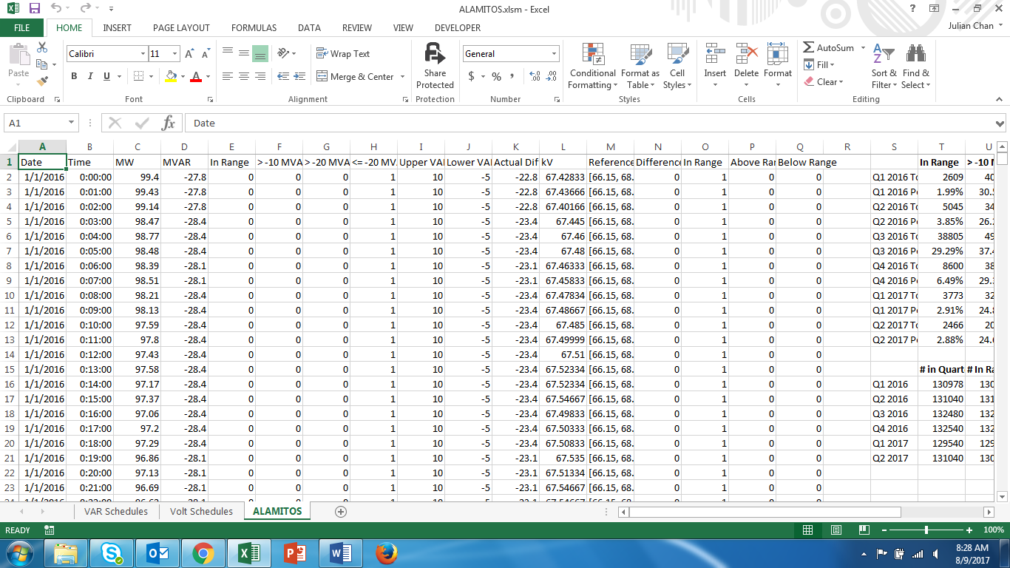

Data

Volt Schedules

VAR Schedules

**Appendix: Usage of the Substation Name**

2

* The substation name is not checked for correctness
* The name entered here will be the name that is used in the title of the plots

**Appendix: Choosing the Bound Type**

3

* Refer to the System Operating Bulletin, Number 17 (SOB-17) for corresponding Voltage and VAR Schedules
  + At the time of creation of this program, the SOB-17 was used for 500 kV, 115 kV, and 66 kV substations
  + For future expansion to other voltage levels, the types of bounds might change and the program does not support these different bounds
* The 4 bound types apply only to Voltages; the VAR schedule is always in the following format:
  + Low MW – High MW Low MVAR – High MVAR
* See the next page for examples of the different types of bounds and how they appear in the SOB-17

|  |  |
| --- | --- |
| **All Times** | **Range** |
| **Load Dependent** | **Load Dependent Range** |

**Appendix: Entering the Bounds**

4

* **IMPORTANT:** Please make sure that the High MW of the previous row is exactly equal to the Low MW of the current row
  + For example, if the VAR Schedule was:

|  |  |
| --- | --- |
| **MW** | **MVAR** |
| 0 – 200 | +5 to -10 |
| 201 – 300 | -5 to -25 |
| Above 301 | -20 to -40 |

You would need to enter:

|  |  |  |  |
| --- | --- | --- | --- |
| **Low MW** | **High MW** | **Low MVAR** | **High MVAR** |
| 0 | 200 | -10 | 5 |
| 200 | 300 | -25 | -5 |
| 300 |  | -40 | -20 |

* See the next 3 pages for examples of how to fill in the bounds given the SOB-17’s from Page 8

**All Times**

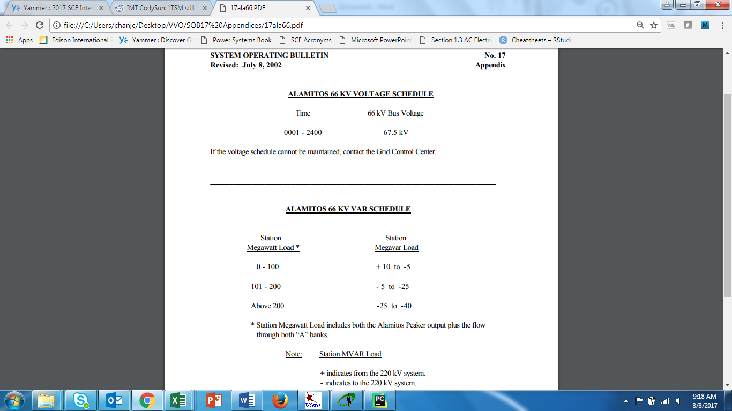

|  |  |  |  |  |  |  |  |
| --- | --- | --- | --- | --- | --- | --- | --- |
| Low MW | High MW | Low MVAR | High MVAR |  |  |  | Voltage |
| 0 | 100 | -5 | 10 |  |  |  | 67.5 |
| 100 | 200 | -25 | -5 |  |  |  |  |
| 200 |  | -40 | -25 |  |  |  |  |

**Range**

530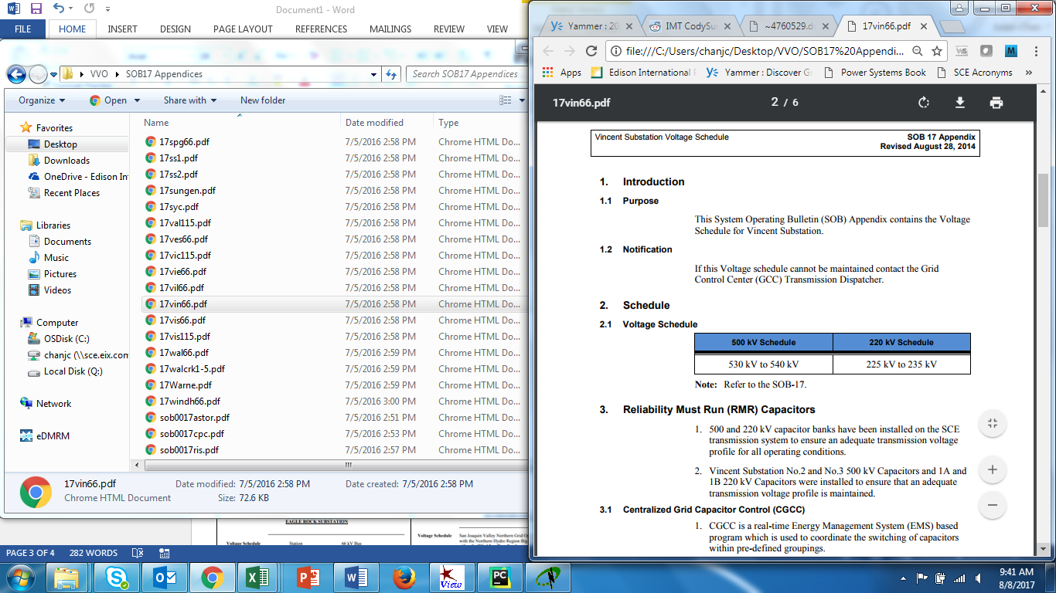

|  |  |  |  |  |  |  |  |
| --- | --- | --- | --- | --- | --- | --- | --- |
| Low MW | High MW | Low MVAR | High MVAR |  |  | Low Voltage | High Voltage |
| xx | xx | xx | xx |  |  | 530 | 540 |
| xx | xx | xx | xx |  |  |  |  |
| xx | xx | xx | xx |  |  |  |  |

**Load Dependent**

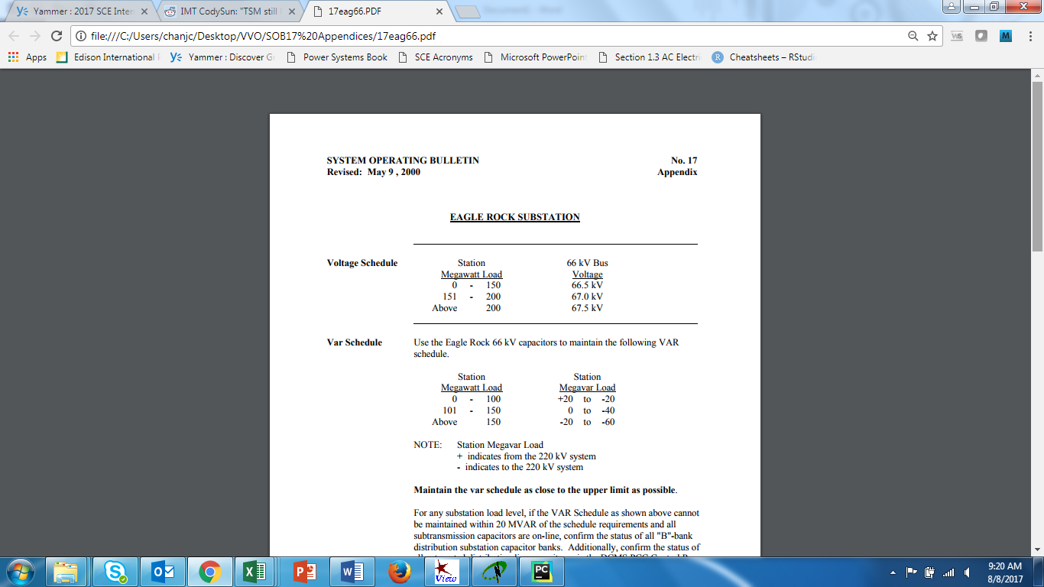

|  |  |  |  |  |  |  |  |
| --- | --- | --- | --- | --- | --- | --- | --- |
| Low MW | High MW | Low MVAR | High MVAR |  | Low MW | High MW | Voltage |
| 0 | 100 | -20 | 20 |  | 0 | 150 | 66.5 |
| 100 | 150 | -40 | 0 |  | 150 | 200 | 67 |
| 150 |  | -60 | -20 |  | 200 |  | 67.5 |

**Load Dependent Range**

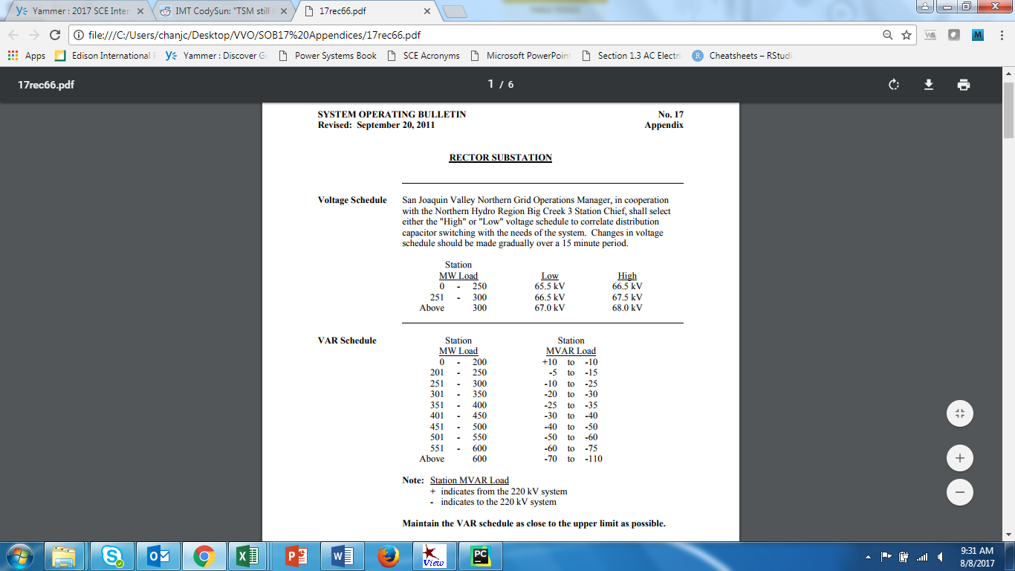

|  |  |  |  |  |  |  |  |
| --- | --- | --- | --- | --- | --- | --- | --- |
| Low MW | High MW | Low MVAR | High MVAR | Low MW | High MW | Low Voltage | High Voltage |
| 0 | 200 | -10 | 10 | 0 | 250 | 65.5 | 66.5 |
| 200 | 250 | -15 | -5 | 250 | 300 | 66.5 | 67.5 |
| 250 | 300 | -25 | -10 | 300 |  | 67 | 68 |
| 300 | 350 | -30 | -20 |  |  |  |  |
| 350 | 400 | -35 | -25 |  |  |  |  |
| 400 | 450 | -40 | -30 |  |  |  |  |
| 450 | 500 | -50 | -40 |  |  |  |  |
| 500 | 550 | -60 | -50 |  |  |  |  |
| 550 | 600 | -75 | -60 |  |  |  |  |
| 600 |  | -110 | -70 |  |  |  |  |

**Appendix: Plot Generation**

5

* Please make sure that all sections are thumbs up before clicking the “Generate Summary Report” button
* The plots will be saved in a PDF file located in the same directory as the Microsoft Excel file selected in Step 1 and will be named the same as the substation name entered in Step 2

**Notes**

* Batch process currently not supported because SOB-17 ranges need to be entered manually instead of being read from an Excel file.
* This program was created to generate reports for the 500kV, 115kV, and 66kV substations. As such, usage of this program is not suitable to generate reports for other voltage levels whose operating procedures differ from the SOB-17’s format.